**Installation guide**

# Introduction

Hotel management application is a desktop application which could be utilized to reduce the management efforts of the hotel business operators. The application consists of several important features such as room status, customer personal information and booking’s information of customers to help managers easily monitoring the hotel’s state and digitalize documentations with lesser efforts.

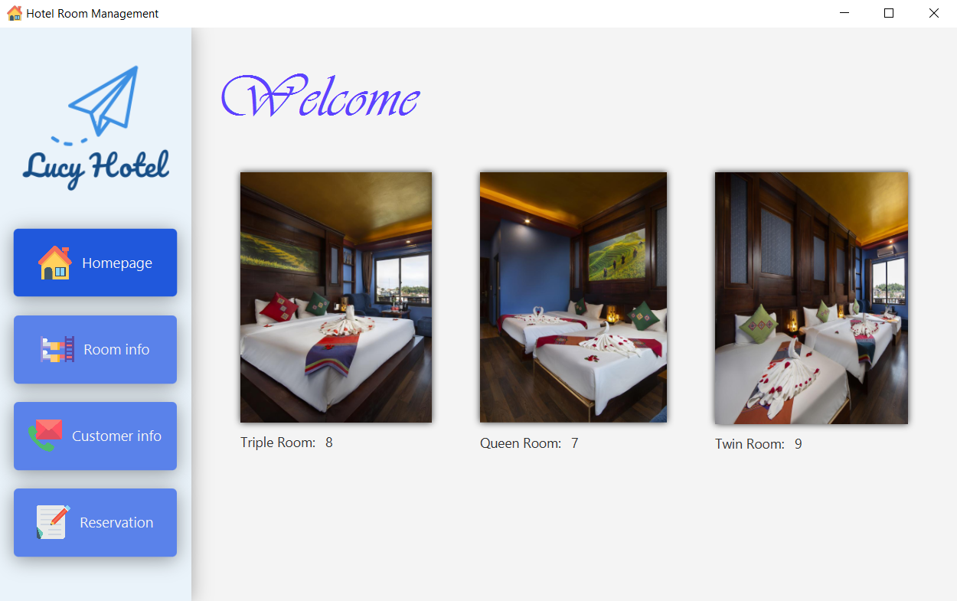

**Figure 1: Homepage**

The desktop application version, is developed with clean-looking and user-friendly interface which could be helpful for multiple usage purposes. This version includes four main pages with different purposes as follows:

* Homepage, provides a general looking of the hotel management by displaying the available rooms and some room previews according to the room’s type.
* Room information page, lists out the entire hotel’s rooms with their current status. Additionally, on this page, the managers can also either edit, delete or updating a specific room.
* Customer information page, shows all customer’s registered personal information once booked a room in current hotel, together with their previous booking information.
* Booking page, allows receptionist to register a new customer by simply entering all of their required personal information. However, if the customer is already registered, their previous information can also be retrieved from the database.

# Requirements

To launch the desktop application version, these requirements must be installed beforehand:

* Apache Maven 3.6.3, for managing the libraries utilized in the project, you can download [here](https://maven.apache.org/download.cgi).
* Java SE Runtime 11, to run the java application, you can download from [here](https://www.oracle.com/java/technologies/javase/jdk11-archive-downloads.html).
* Java SDK 15 or above, for developments purpose (optional), download from [here](https://www.oracle.com/in/java/technologies/javase-jdk15-downloads.html).
* JavaFX SDK 15 or above, for the desktop UI of the application, download from [here](https://gluonhq.com/products/javafx/).
* MySQL Server 8.0 or above, for hosting local MySQL database, download from [here](https://dev.mysql.com/downloads/mysql/).
* Tomcat 9.0, for deloying the web-server locally, download from [here](https://tomcat.apache.org/tomcat-9.0-doc/setup.html).

# Configuration

1. Install the dependencies as listed above.
2. Setup MySQL database

* To set up the local database, please find and execute the SQL script named **“sqlConfig.sql”**.

# Run application

1. Deploy and run web-server

* Go to server’s folder named **“hotelServer”**: *cd hotelServer*
* Deploy with cargo plugin by: *mvn cargo:deploy*
* Run Tomcat’s server by running startup.bat from your Tomcat directory. By default, it locates at C*:\Program Files\Apache Software Foundation\Tomcat 9.0\bin\startup.bat*
* The web server should be in “localhost:8080/hotelmanagement”.
* Further information: [click here](https://www.baeldung.com/tomcat-deploy-war)

1. Run application

* Go to JavaFX client’s folder: cd hotelClient
* Run JavaFX using the following command: *mvn javafx:run*

Optional (for developers):

* Build package by using command: mvn package
* Run “.jar” file by *“java --module-path <your-javafx-sdk-path> --add-modules javafx.controls javafx.fxml -jar target\hotelmanagement-1.0-SNAPSHOT.jar”*
  + Download JavaFX SDK from [here](https://gluonhq.com/products/javafx/).
  + Place JavaFX SDK as your favourite
  + Add your JavaFX SDK path to the command. **Example:** *“java --module-path E:\javafx-sdk-15.0.1\lib --add-modules javafx.controls,javafx.fxml -jar target\hotelmanagement-1.0-SNAPSHOT.jar”.*

# Troubleshooting

1. Fixing *“UnaccessibleObjectException: Unable to make field private final java.time.LocalDate java.time.LocalDateTime.date accessible: module java.base does not "opens java.time" to module gson”*.

* Java 13 might be not properly worked in this setup, since some updated classes affect the module “gson” which is implemented to communication with web-server via JSON (JavaScript Object Notation)
* To fix this error, you must install the **Java Runtime 11** or changing the enviroment variables to **Java version 11** (if you have another Java version installed on your computer). Otherwise, it won’t work.

2. Fixing *“NullPointerException”*

* This error occurs when the database is not properly installed. To fix this error, you must execute the “sqlConfig.sql” before running the web-server to make sure that data is available to fetch.

3. Fixing *“Port 8080 required by Tomcat v8.0 Server at localhost is already in use. There may already be running in another process, or a system process may be using the port. To start this server you will need to stop the other process or change the port number(s)”*.

* This errors cause as port 8080 is being occupied by another process.
* To fix this error, you need to follow step-by-step:
  + **Step 1:** Find the proces id that is using the port 8080: *netstat -ano | findstr 8080*.
  + **Step 2:** Open command as administrator and kill the process: *taskkill /F /pid <pid>*.

# Details setup

## A. MySQL installation

1. Get can get MySQL Workbench and Server from here, you can use any MySQL workbench as your favourite, however, for convenient MySQL Workbench 8.0 CE is installed in this tutorial.
2. Install MySQL pack including MySQL Workbench and MySQL Server.

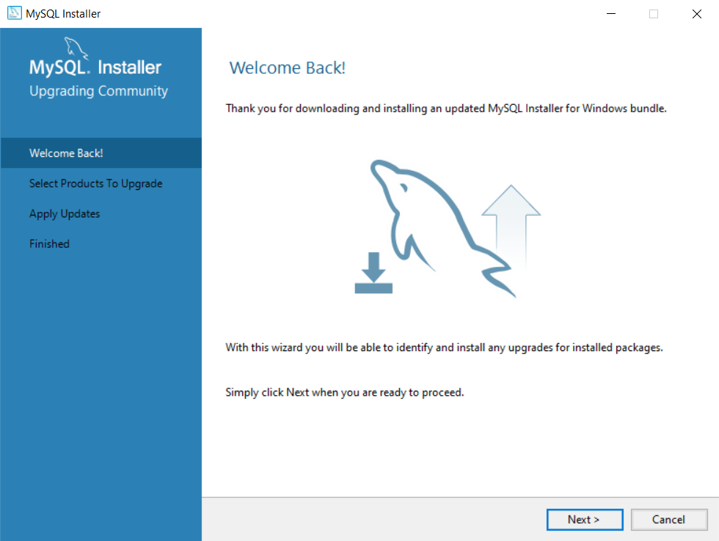

**Figure 2: Welcome page**

**Step 1:** Click the “Next” button to continue the installation

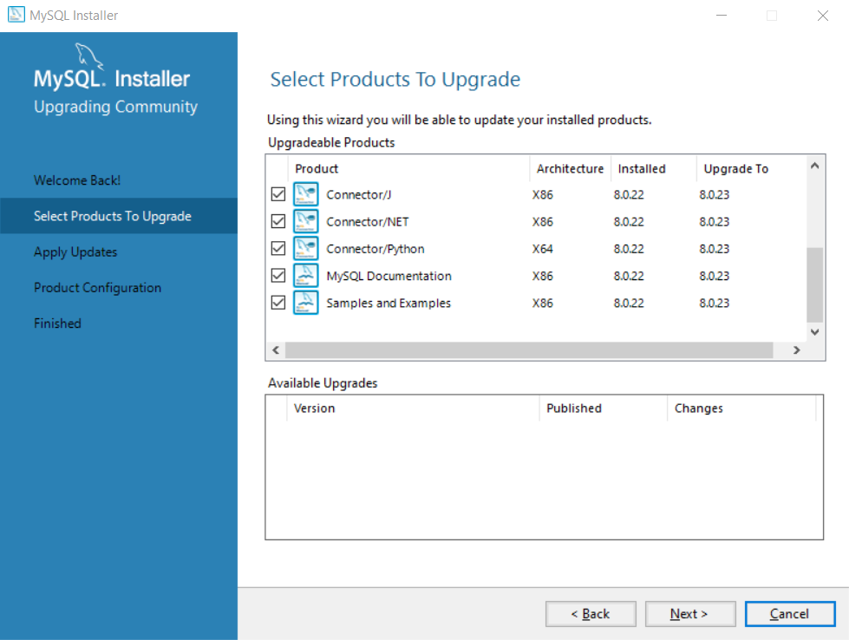

**Figure 3: Select product to install**

**Step 2:** Select the components that you would like to install. However, it’s recommended that you should select all to make sure all components are installed for future usage. Then, click on the “Next” button to continue the installation.

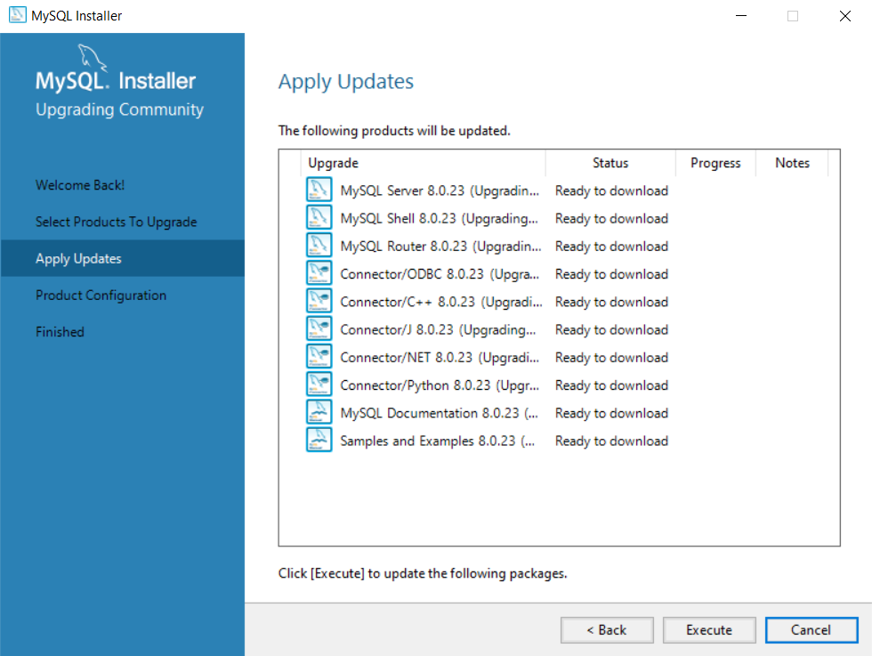

**Figure 4: Apply updates & downloads**

**Step 3:** You will have to wait for the installer to download all of the components. Click on the **“Execute”** button and wait for the downloading. It should take a while to complete the downloads.

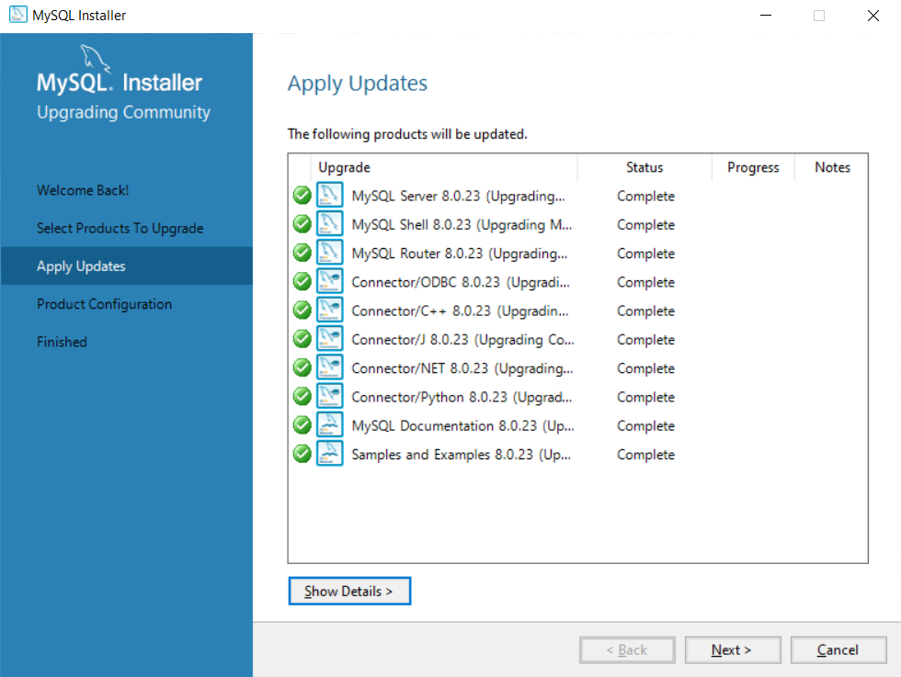

**Figure 5: Apply Updates completed**

**Step 4:** After downloading is complete, click on the “Next” button again to the next procedure

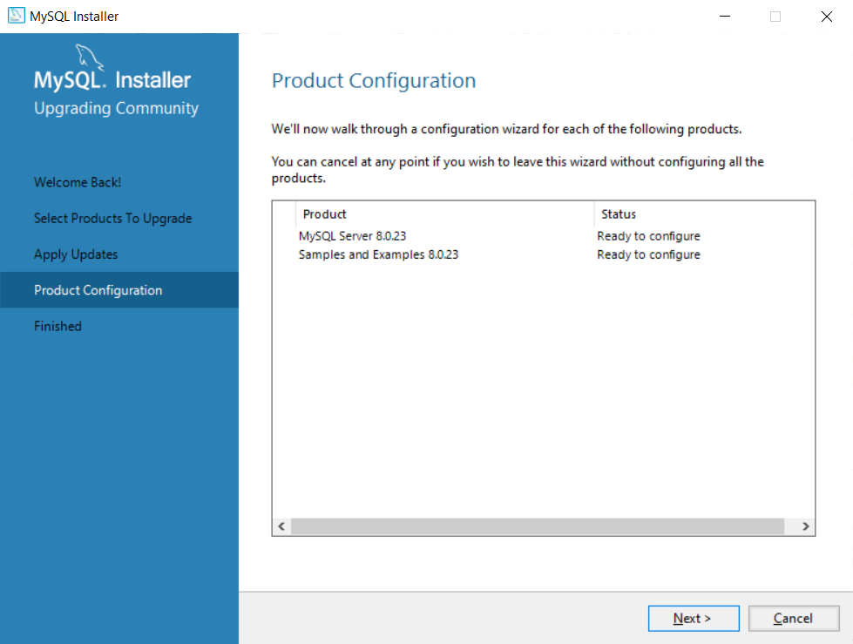

**Figure 6: Product Configuration**

**Step 5:** Click on the “Next” button to continue

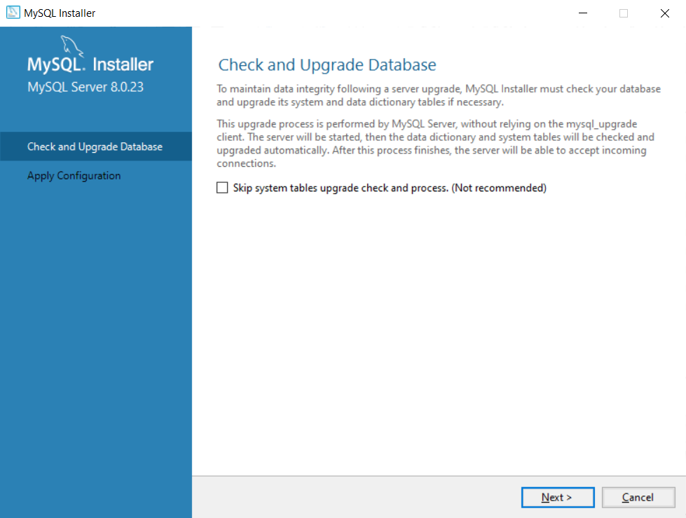

**Figure 7: Check & Upgrade Database**

**Step 6** *(Optional)*: You can skip this step. However,it doesn’t makes sure that the database configuration is up-to-date.

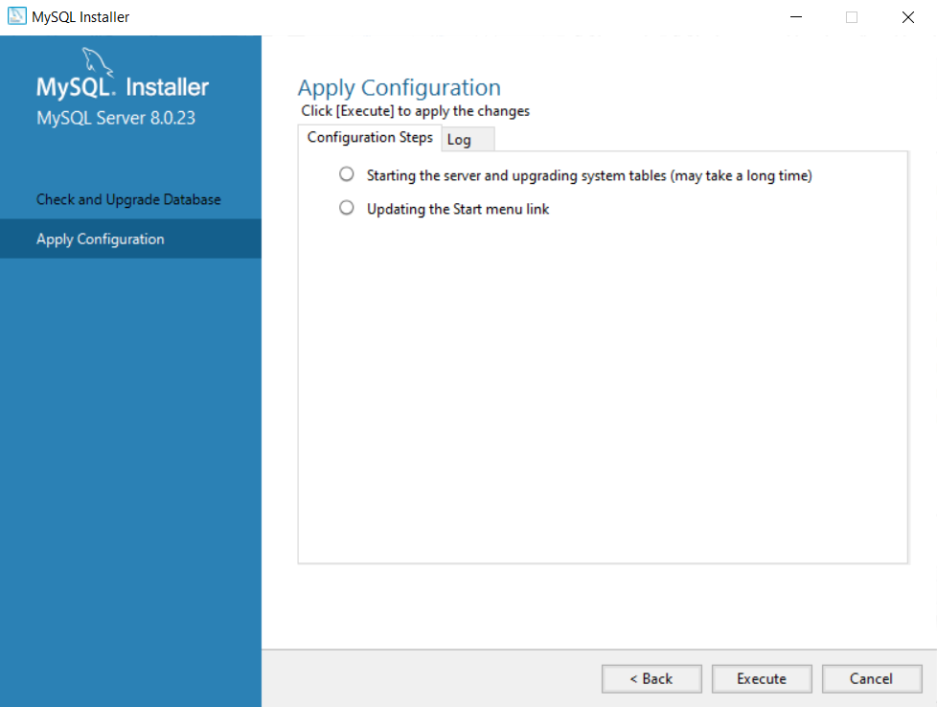

**Figure 8: Apply the configuration**

**Step 7:** Click on the “Execute” button to apply the configuration.

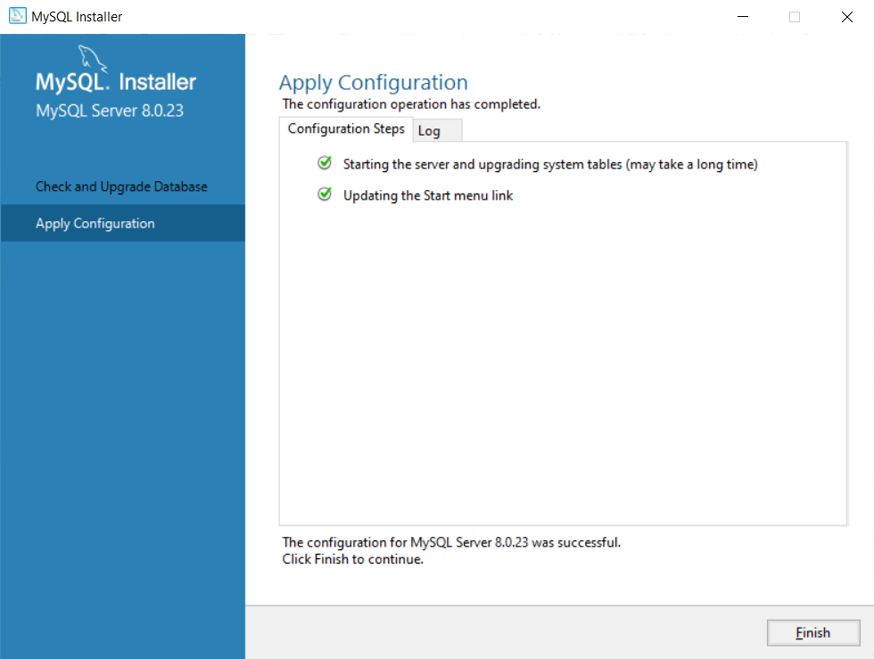

**Figure 9: Apply configuration**

**Step 8:** Click on the “Finish” button to finish the upgrade.

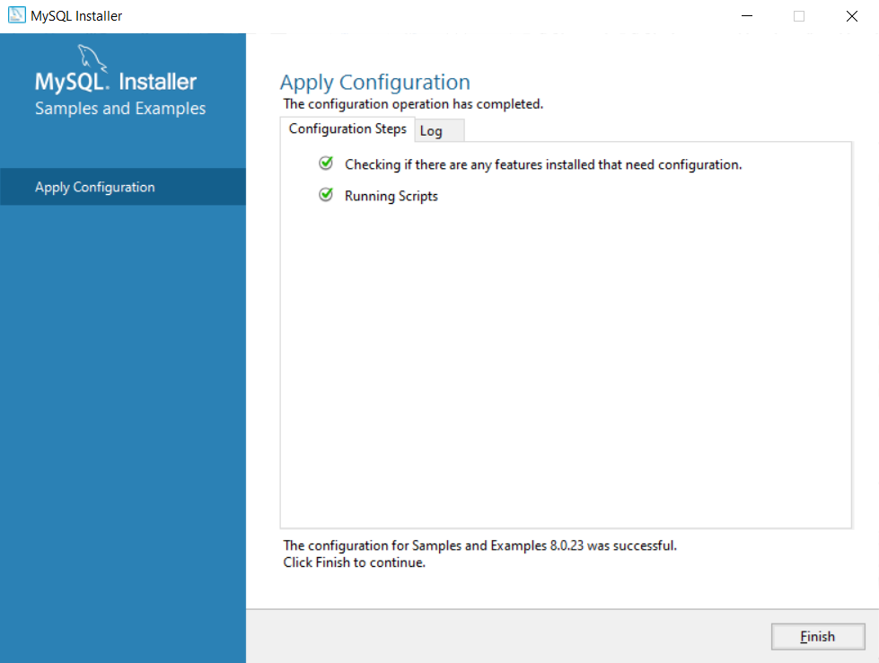

**Figure 10: Apply Configuration**

**Step 9:** Click “Finish” button to confirm the applied configuration.

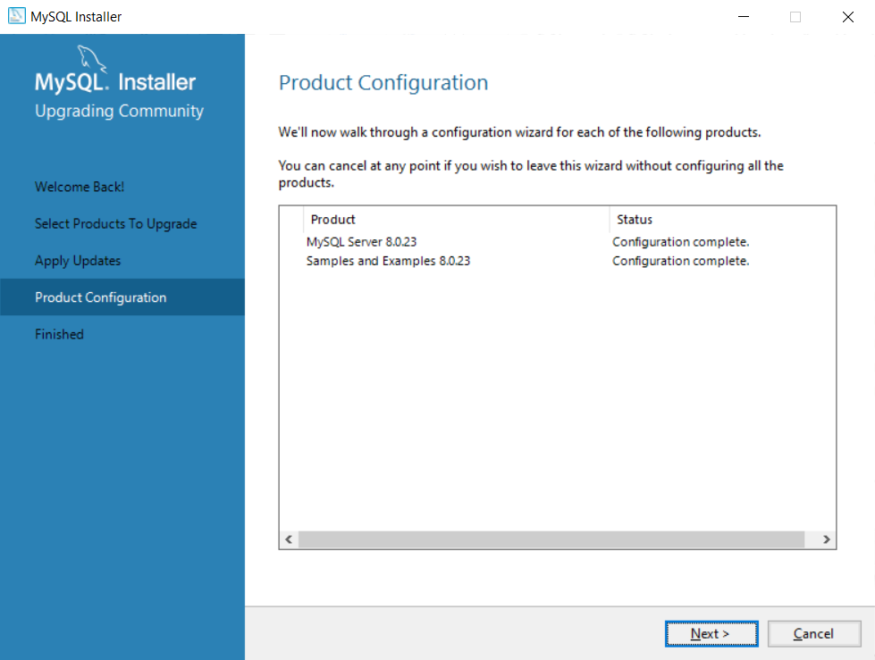

**Figure 11: Product Configuration**

**Step 10:** Click on the “Next” button to confirm the configuration.

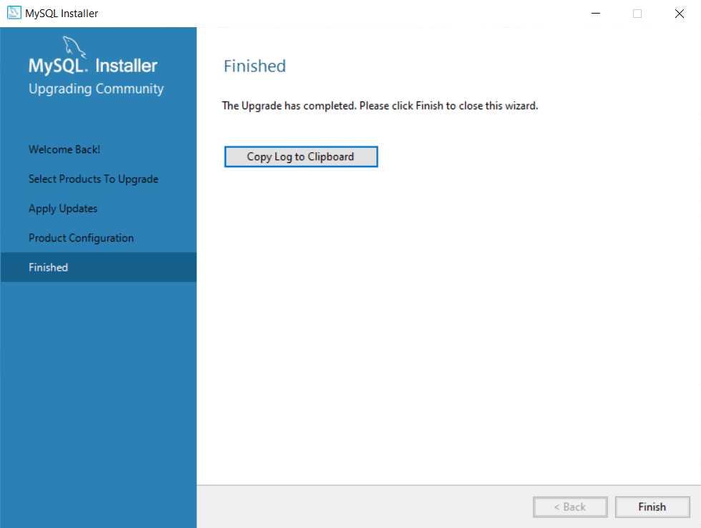

**Figure 12: Finished**

**Step 11:** Click on “Finish” button to complete the installation.

## **B. Tomcat installation**

**Step 1: Download Apache Tomcat**

* Navigate [here](https://tomcat.apache.org/download-90.cgi)
* Choose the file named **32-bit/64-bit Windows Service Installer (pgp, sha512)** to download

**Step 2: Setup**

* Choose the **full** option after download the **Step 1** file like below image

[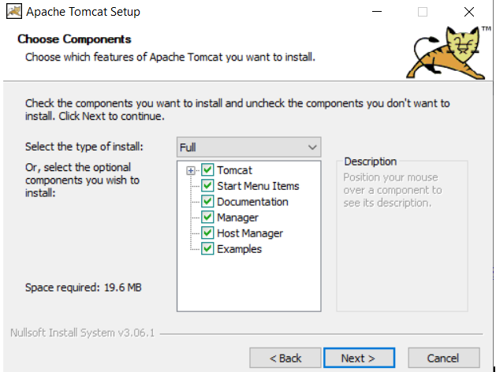](https://user-images.githubusercontent.com/52565807/111071856-a89d9980-850a-11eb-8a3f-5833e6b016af.PNG)

**Figure 13: Apache Tomcat Setup**

* Fill in the **user** and **password** form like below image

[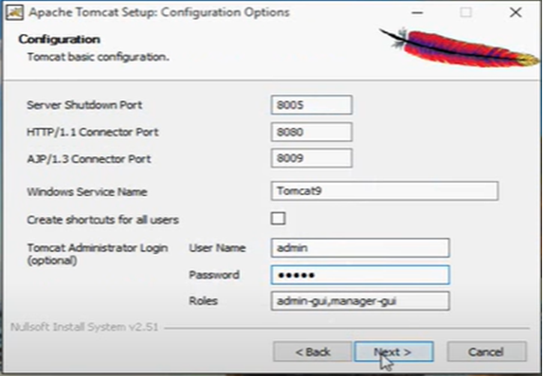](https://user-images.githubusercontent.com/52565807/111071867-b2bf9800-850a-11eb-8e50-9a35e0662d1c.PNG)

**Figure 14: Tomcat configuration**

**Step 3: Check if success**

* Navigate to **localhost:8080** on your web browser
* The below image indicates you have successfully installed Apache Tomcat 9 to your computer

[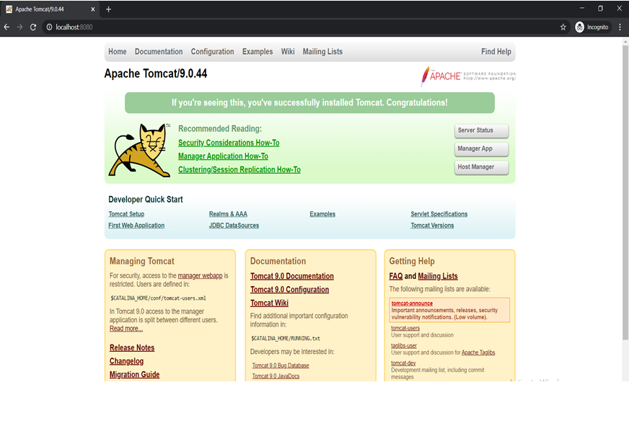](https://user-images.githubusercontent.com/52565807/111071871-b81ce280-850a-11eb-91b5-560309ceface.PNG)

**Figure 15: Tomcat successfully install**

## **C. Maven installation**

**Step 1: Make sure Java has already been downloaded**

* Download **Java-JDK** (the latest version), you can download it from [here](https://www.oracle.com/java/technologies/javase/jdk15-archive-downloads.html)

**Step 2: Create a user environment variable with following figures**

* Name: **JAVA_HOME**
* Value: the directory to the path of **Java-JDK** stored in your computer

**Step 3: Create a system environment variable (Path variable) with following figures**

* + Variable: **Path**
  + Value: the directory path to the **bin** folder of the **Java-JDK** stored in your computer

**Step 4: Download Apache Maven**

* + Navigate to [here](https://maven.apache.org/download.cgi) to download Apache Maven

**Step 5: Create 2 user environment variables with following figures**

* + Name: **MAVEN_HOME** and **M2_HOME**
  + Value: the directory path to the **Apache Maven** version you just downloaded

**Step 6: Create a system environment variable (Path variable) with following figures**

* + Variable: **Path**
  + Value: the directory path to the **bin** folder of the **Apache Maven** version you just downloaded

**Step 7: Check whether you have successfully downloaded Maven**

* + Type command **mvn -version** to the command prompt
  + The below picture indicates that Maven has been successfully installed

[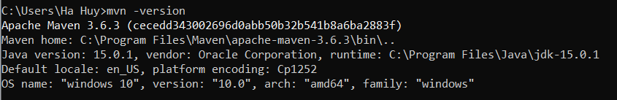](https://user-images.githubusercontent.com/52565807/111071356-552a4c00-8508-11eb-8ad7-d8c574d86109.PNG)

Figure 16: Maven successfully install

## D. JavaFX SDK setup

**Step 1:** Download the JavaFX SDK package from [here](https://gluonhq.com/products/javafx/) and exact to the folder you wish.

**Step 2:** Note your JavaFX SDK. It could be useful later on.

User Manual

The Hotel management application includes four main pages which are displayed in the left vertical taskbar of the application and arranged downward, such as Homepage, Room Info, Customer Info and Reservation respectively. Furthermore, this application also contains several of functions that support hotel staffs to manage easier.

A. Homepage

First of all, after successfully running the application, a homepage will display to user.



The Hotel consists of three types of room, Triple Room, Queen Room and Twin Room which are displayed in the Homepage to simplify the management of the available rooms. Following that is the number of the available rooms.

B. Room Info

The Room Info contains all the information of hotel rooms displayed through a table. The table includes Room Number, Room Type and Room Status. The Room Number is unique and obviously different from each other. The Room Type, which are Triple Room, Queen Room and Twin Room, are distributed to every room number. The Room Status has three options, such as, Available, Reserved and Staying. Available status will be counted and sorted by Room Type, then shows the amount of available rooms on Homepage. When customer successfully makes a reservation through telephone or on desk with hotel staff, the status for reserved room(s) will change from Available to Reserved. After that, on the reserved date, the Status of that room will automatically change to Staying status.

Above the table are five functions which are Sort by Room Type, Sort by Room Status, Edit, Delete and Add Room.

The room information can be sorted by Room Type, by Room Status or by both. For each sorting option, hotel staffs have four choices, which are All, Twin Room, Triple Room, Queen Room for Room Type, and All, Available, Reserved, Staying for Room Status. Three figures below shows three ways for hotel staffs to sort the room information.

Hotel staffs are able to edit or delete room information through following steps.

* Step 1: Choose a room to modify
* Step 2: Click Edit or Delete button
* Step 3:
* Edit Room: Because of unique room number, the hotel staffs cannot change it, however they can change the other two information by choosing either Room Type or Room Status by combo boxes.

* Delete Room: The hotel staffs will choose OK if they ensure to remove that room from the database. Otherwise, they will return to the previous state.

After that, the room information has been changed in the table

In contrast, if hotel staff do not choose a room in the table, the system will show the error dialog, which are showed in a below figure. Similarly, before deleting a room, hotel staffs must choose a room in the table. If not, the system will show the error dialog.

The last function in this Room info page is Add Room. By those following steps, the hotel staffs will be able to create a new room.

* Step 1: Choose Add button
* Step 2: Fill all the information
* Step 3: Click OK, then the room is successfully created. Otherwise, no room will be added to the database.

In step 2, if they miss some needed information, the system will display an error dialog

C. Customer Info

On the left side of the third page, Customer Info, there are a Search box and a table which consists of Customer ID, First Name and Last Name. And on the right side, it shows all personal information except Customer ID and a Show booking info button which includes all booking information of customer.

First of all, hotel staffs can search their known information about customer in the Search box, for example, 1, W, Gina, etc. The table automatically filter the customer information based on what they searched.

If hotel staffs do not choose any customer information in the table, the personal information is empty. Otherwise, it is filled with all detailed information.

As mentioned above, Show booking info shows all booking information of the chosen customer.

In this dialog, it contains the table with all booking information, such as, Booking ID, Check-in Date, Check-out Date, Booking Method and Room Number. The Check-in After box and Check-out Before box is to sort out the Booking information of the chosen customer.

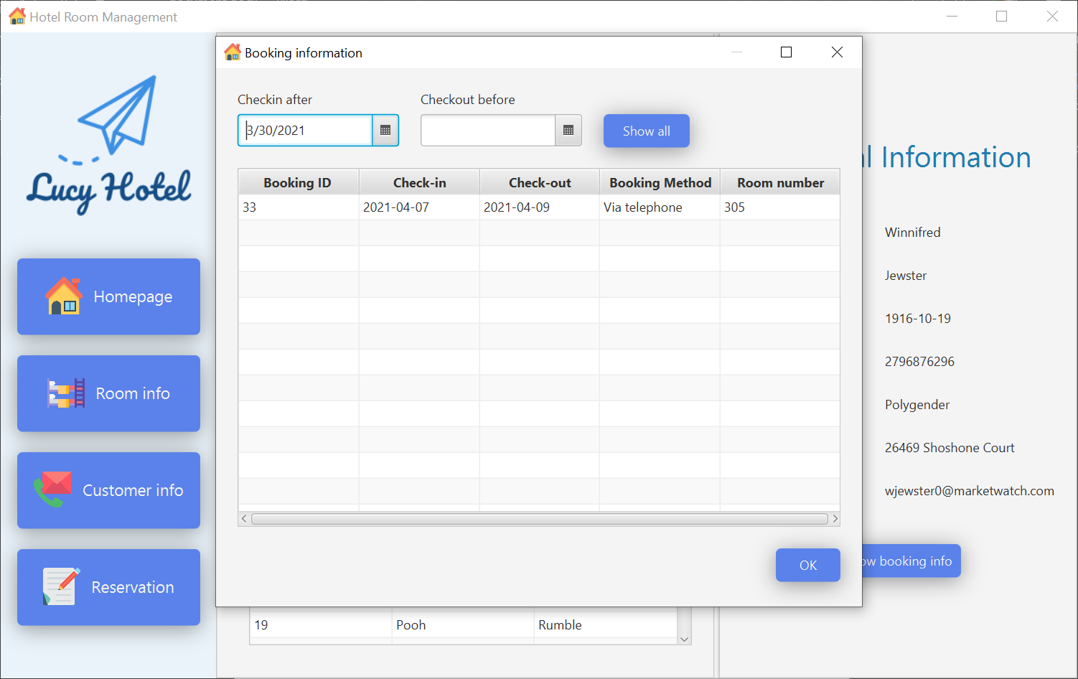

There is a Show All button which shows all booking information again after sorting.

D. Reservation

The Reservation page helps hotel staffs receive the booking information from customer at desk or via telephone.

After hotel staffs open the Reservation page, the blank form will appears which can be fill in by two different ways

* Option 1: For customers who had already stayed in the hotel, hotel staffs click Choose customer button. Next, the dialog, which imitates Customer info page, opens.

Following that, the customer information who is making reservation, then click OK. Finally, all the needed information is automatically filled in the form.

Last but not least, the hotel staff insert all booking information and submit the reservation.

In option 1, it consists of the last function of the application which is + New. This function helps hotel staffs after having a wrong information, they can refresh to the blank form.

* Option 2: For new customers, hotel staffs input all Personal Information and Booking Information by hand and then submit the booking.

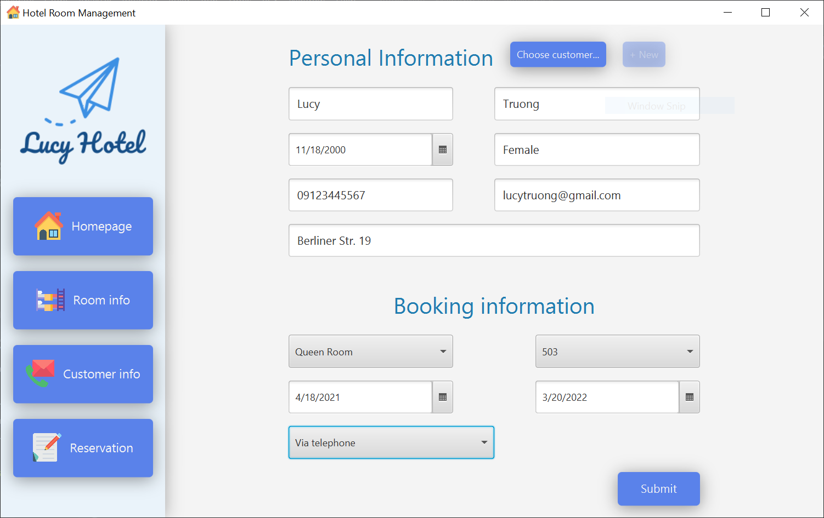

Since all the information is important, the error dialog will appear whenever the hotel staffs do not

completely fill in the reservation form.

